Assignment-7

Manasa Vathumilli -700745467

**GitHub link**: https://github.com/Manasav17/NNDL-Assignment7

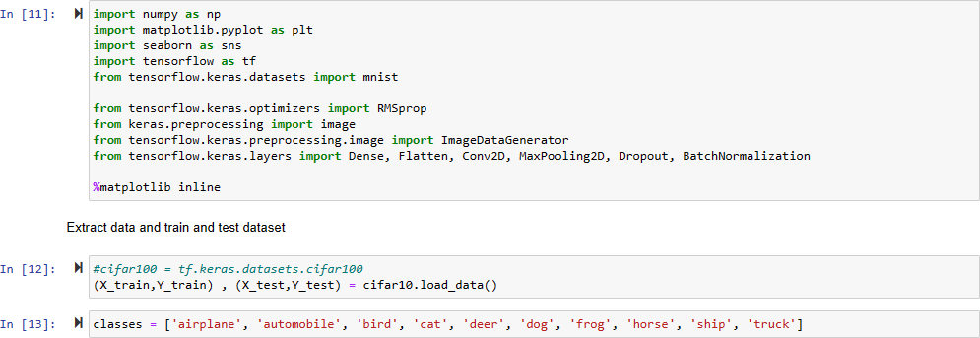

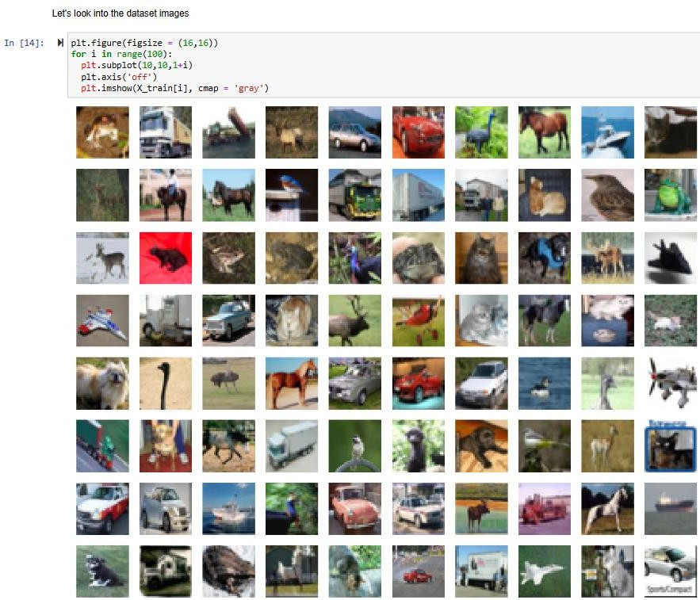

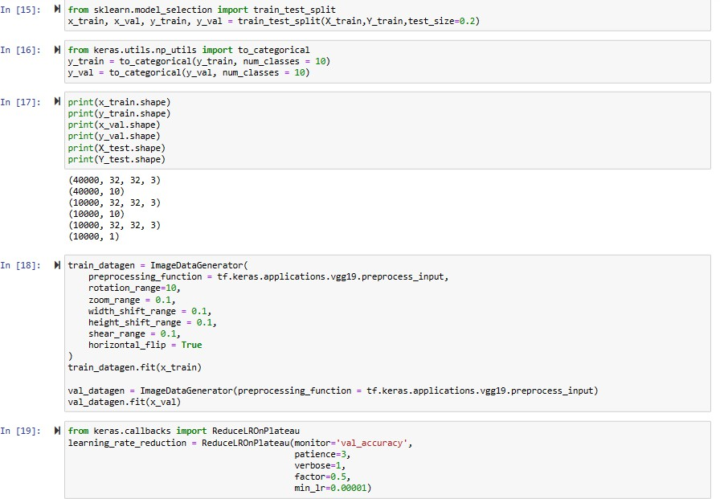

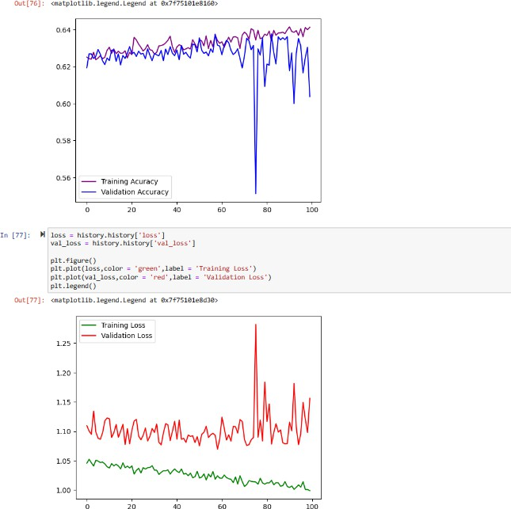

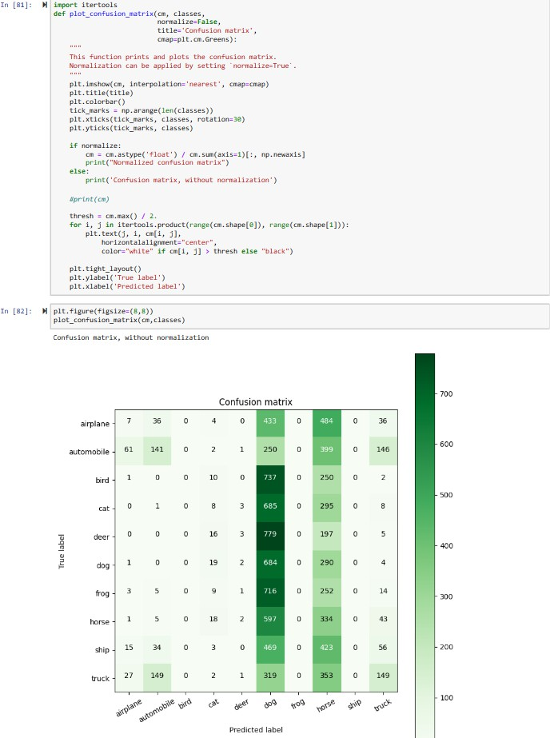

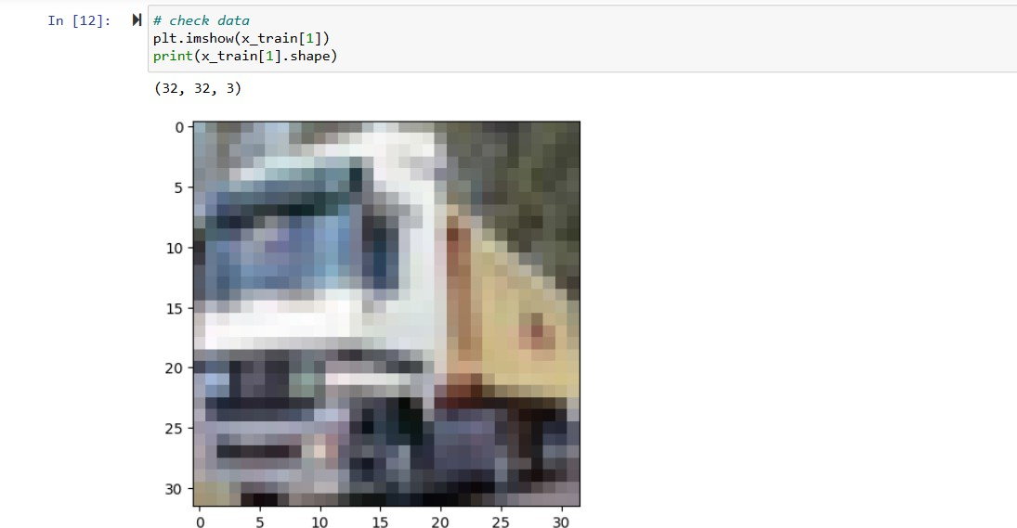

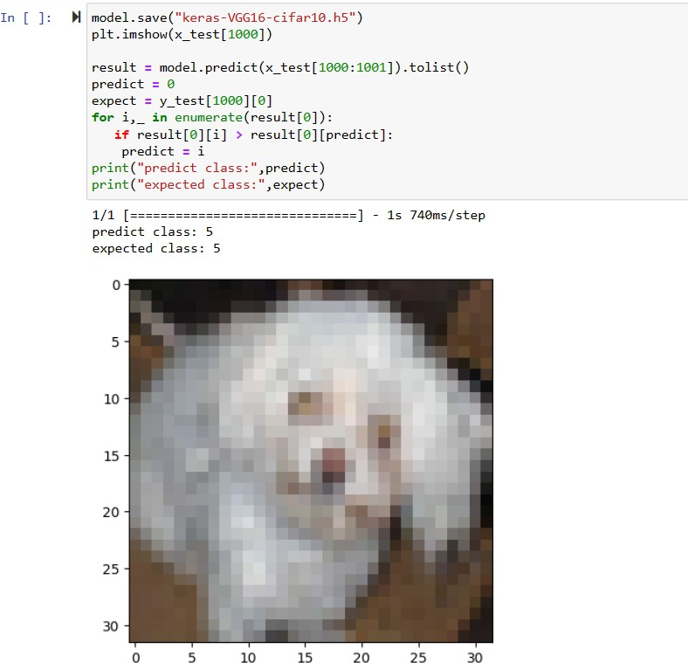

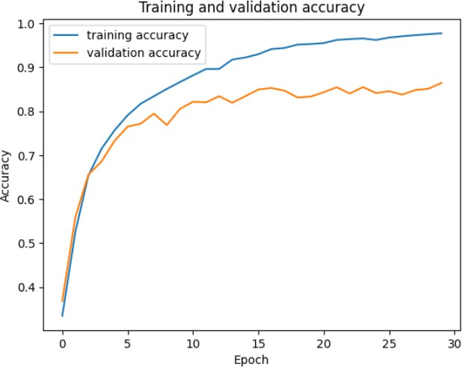

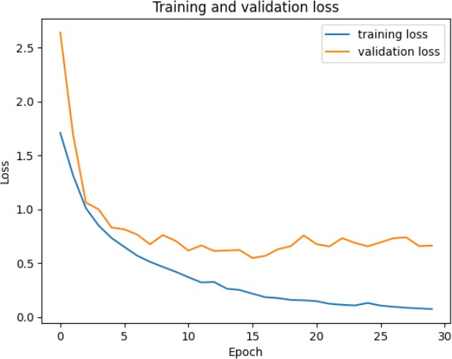

**Description**: In this use case, I have Tuned hyperparameter and made necessary addition to the baseline model in order to improve validation accuracy and reduce validation loss.

and provided logical description of steps that lead to improved response and its impact on architecture behavior and, created two more visualizations using matplotlib.

Used dataset and implemented baseline models. Applied modified architecture dataset and trained it. Evaluated model on testing set. Saved the improved model and used it for prediction on testing data.

then Provided plot of confusion matric, after that, Provided Training and testing Loss and accuracy plots in one plot using subplot command and history object.

Provided two more visualizations reflecting solution. These steps lead to improved response for new dataset when compared with baseline model and enhanced architecture.

Video Link: https://drive.google.com/file/d/1131JX93dY4yoIq3kd2XABizjrB1Zyi0g/view?usp=sharing